FitFlex Documentation

# 1. Introduction

## Project Title:

FitFlex - Inventory Management Application

## Team Members:

Team Leader: K. Dharshanee  
Members: J.S. Andria Alisha, M. Kiruthika, T. Padmapriya, S. Brindha

# 2. Project Overview

## Purpose:

The purpose of FitFlex is to provide a comprehensive and user-friendly inventory management system that allows businesses to effectively manage their products, stock, and sales records.

## Features:

- Dashboard with real-time inventory updates  
- Product management (Add, Update, Delete)  
- Search and filter options  
- Secure user authentication  
- Responsive and intuitive UI

# 3. Architecture

## Component Structure:

The application follows a modular component-based structure using React, enabling reusability and maintainability.

## State Management:

Global state is managed using React Context API/Redux, while local states are handled with useState and useReducer.

## Routing:

React Router is used for seamless navigation between different pages.

# 4. Setup Instructions

## Prerequisites:

- Node.js (v16+)  
- npm or yarn  
- Git

## Installation:

1. Clone the repository  
2. Run `npm install`  
3. Configure environment variables  
4. Start development server using `npm start`

# 5. Folder Structure

## Client:

/src - contains all source code  
/components - reusable components  
/pages - main application pages

## Utilities:

/utils - helper functions  
/config - configuration files

# 6. Running the Application

Frontend:

Open VS code and open terminal and then choose command prompt .

Then type cd code .

Then type npm install.

Then type npm start .  
Run `npm start` to start the development server. The app will be available at http://localhost:3000

# 7. Component Documentation

## Key Components:

- Dashboard: Displays summary of products  
- ProductList: Lists all products  
- ProductForm: Form to add/edit products

## Reusable Components:

- Button  
- Input  
- Modal

# 8. State Management

## Global State:

Managed using Context API/Redux to maintain authentication and inventory data.

## Local State:

Managed using React useState for UI-related states such as form inputs.

# 9. User Interface

The application has a clean, responsive, and intuitive UI designed with accessibility in mind.

# 10. Styling

## Theming:

Tailwind CSS/Custom CSS is used for styling with light and dark theme support.

# 11. Testing

## Testing Strategy:

Unit tests are written for key components using Jest and React Testing Library.

## Code Coverage:

Test coverage is monitored to ensure code quality.

# 12. Screenshots or Demo

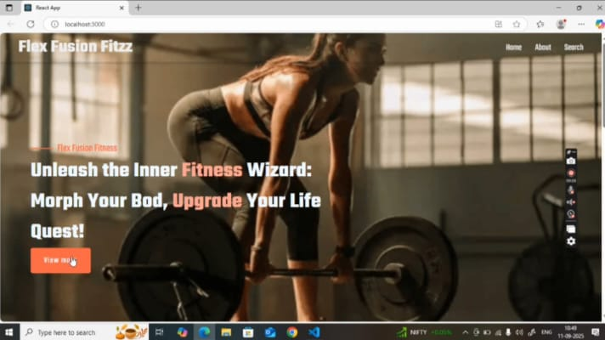

# https://drive.google.com/file/d/1NsAO9-MVVucCfXEii210EytoCUvNECSs/view?usp=drive_link

# 13. Known Issues

- Limited offline support  
- Basic error handling needs improvement

# 14. Future Enhancements

- AI-based stock prediction  
- Multi-language support  
- Advanced analytics and reporting

# Conclusion

FitFlex is a robust inventory management system that streamlines stock management, enhances productivity, and provides valuable insights for businesses. Future updates will focus on scalability, performance improvements, and integration with third-party services.